Ref.N.7
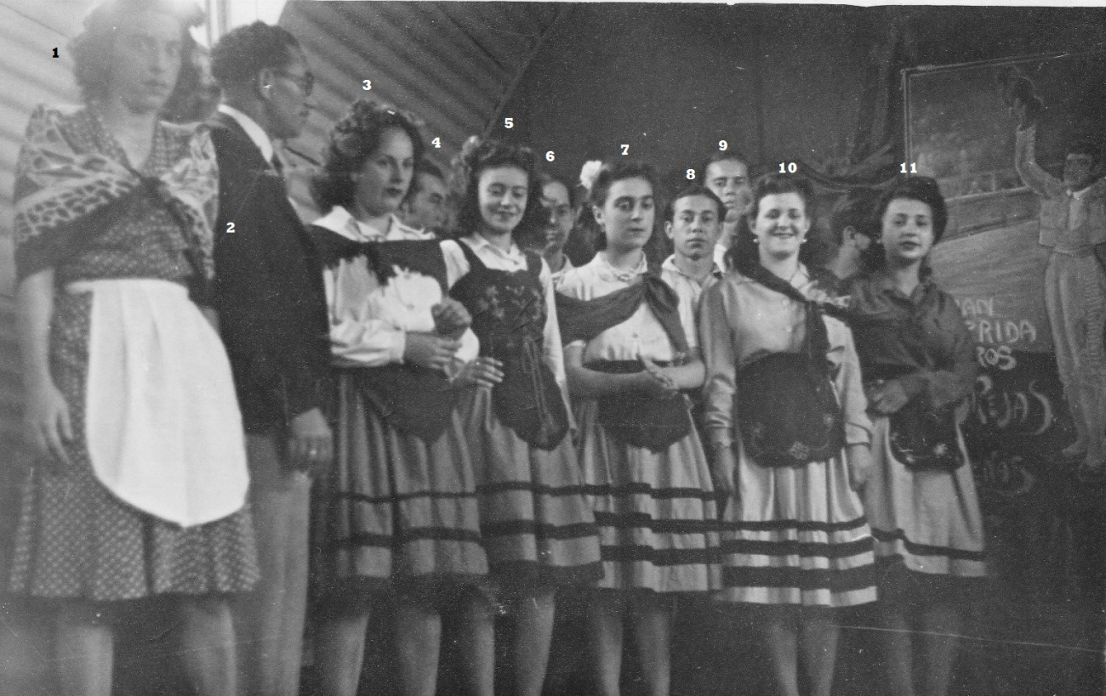
1.Araceli Gonzalez 2. .....?.....3. Lourdes Montegriffo 4. ? 5. Zoraida Hermida(Mrs Santos ) 6 ...?... 7. Olga Cornelio (Mrs Avellano)8...?....9. ....?......10. Lourdes Padina (Mrs Baglietto)11.....?.......

Ref.N.8
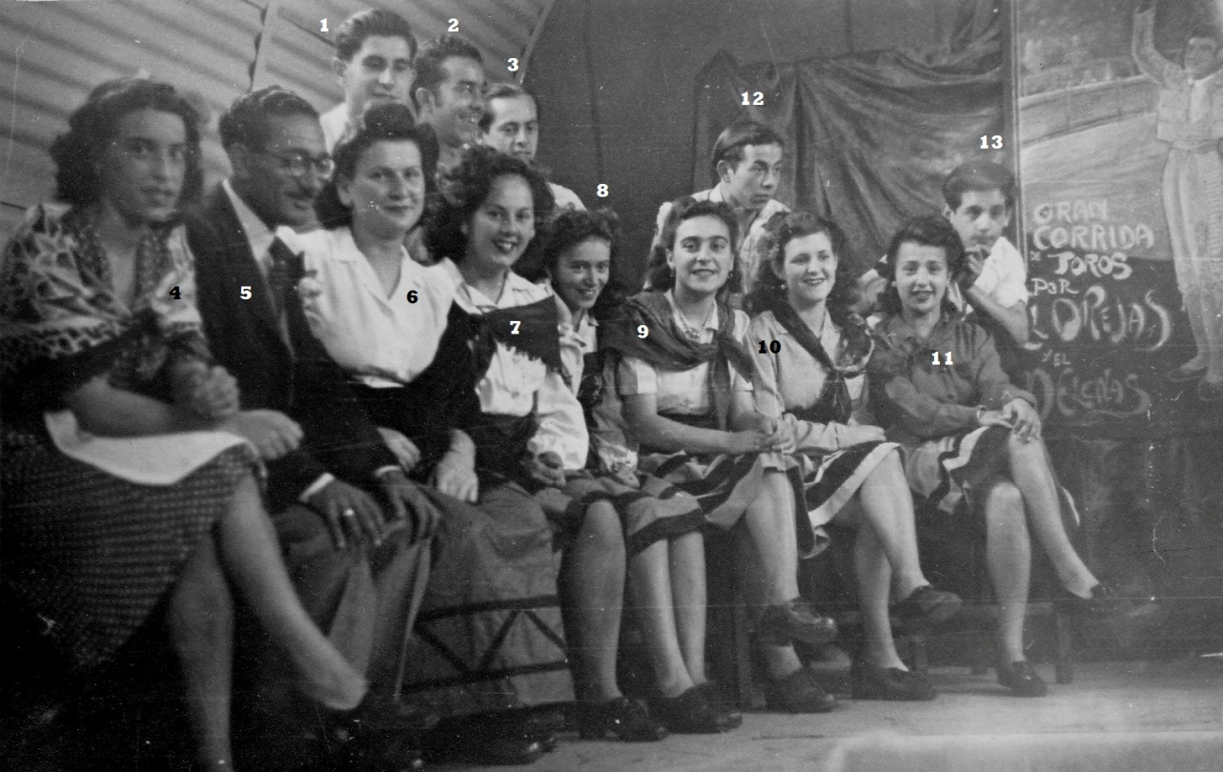
1.....?..... 2......?....... 3.. Claudio Montegriffo
4. Araceli Gonzalez 5.....?.....6.Evelyn Yeo 7. Lourdes Montegriffo 8. Zoraida Hermida (Mrs Santos)9.Olga Cornelio (Mrs Avellano)10. Lourdes Padina(Mrs Baglietto)11....?.....12....?....13.....?.......

