Ref N.1.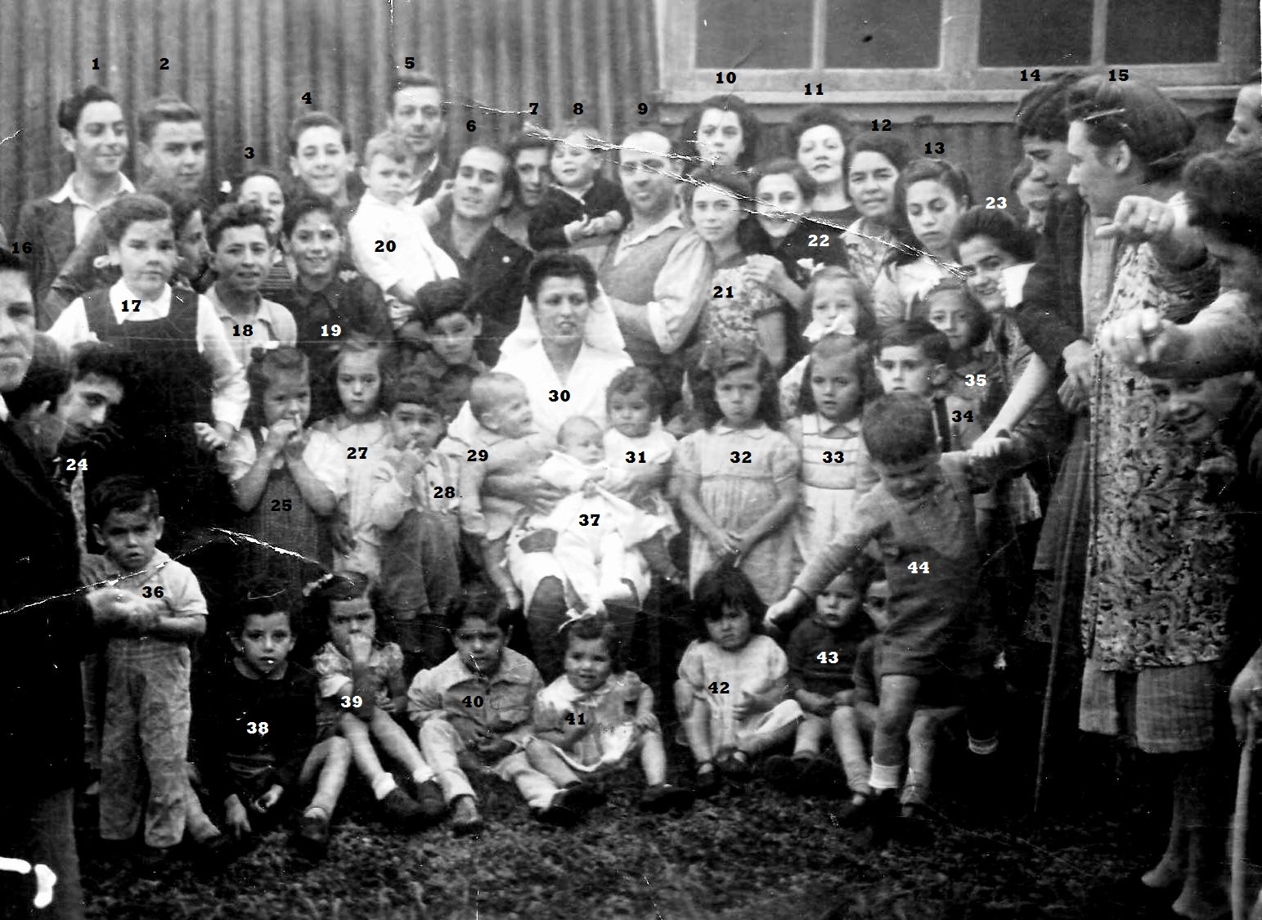Evacuees at Camp No 5 Tawnybrack.
28.Jeffrey Ferrar 6. Mr Guerrero holding his son 20. Andrew Guerrero 34. Mariano Bruzon 18. Johnny Sayers
30. Olga Massetti

