Ref.M.7.
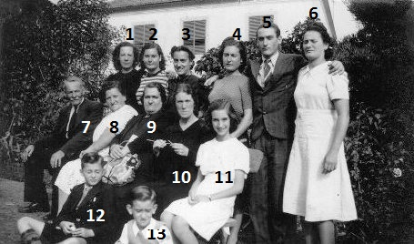
Photo taken in the garden of the Savoy Hotel
1 Clemencia Parody 2 Lourdita Gonzalez 3 Teresa Parody 4 Angelina Gonzalez 5 Andres Ryan?
6 .....Ryan? 7 Adolfo Parody 8 ¿ 9 Lourdes Gonzalez 10 Nina Correa 11Maribel Correa
12 Adolfo Gonzalez 13 Antonio Correa

Ref.M.8
