Ref.L.11.
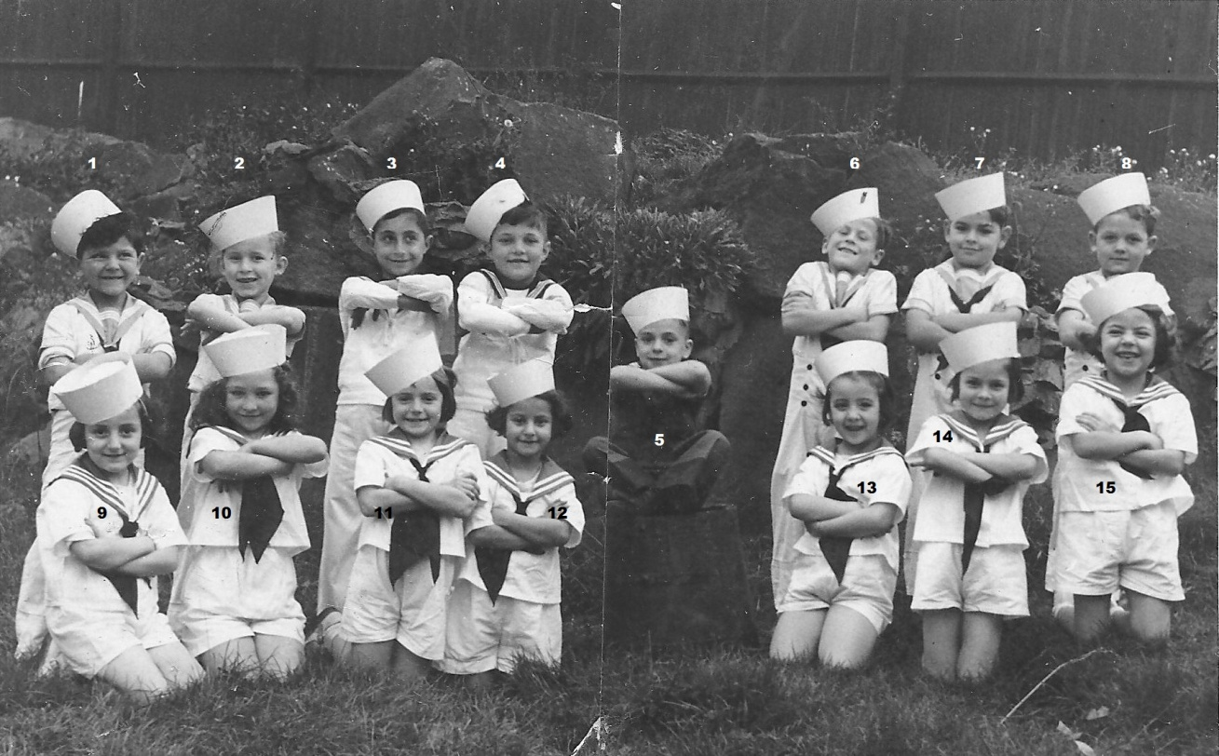
1. ? 2.R.Marshall 3.E.Bensusan 4.H.F.Requena
5.A.Hernandez 6.W.Yeo 7.A.Gomez,...?...,. 9. A.Stagnetto,...?.....,...?....,12. J..Rocca,...?...,...?....,15. L Jeffries.

Ref.L.12.
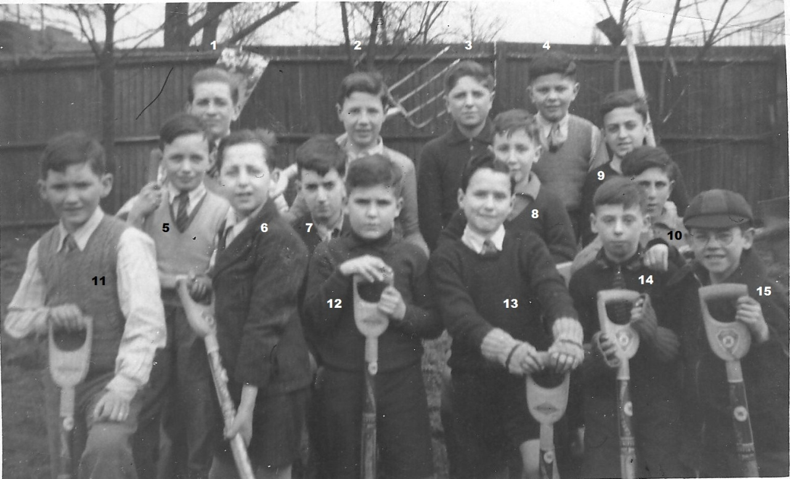
2. E.Apap 3.F.Mosquera 4.E.Azzopardi 11. D.Crome 12.O.Requena rest not known.

