Ref.L.18
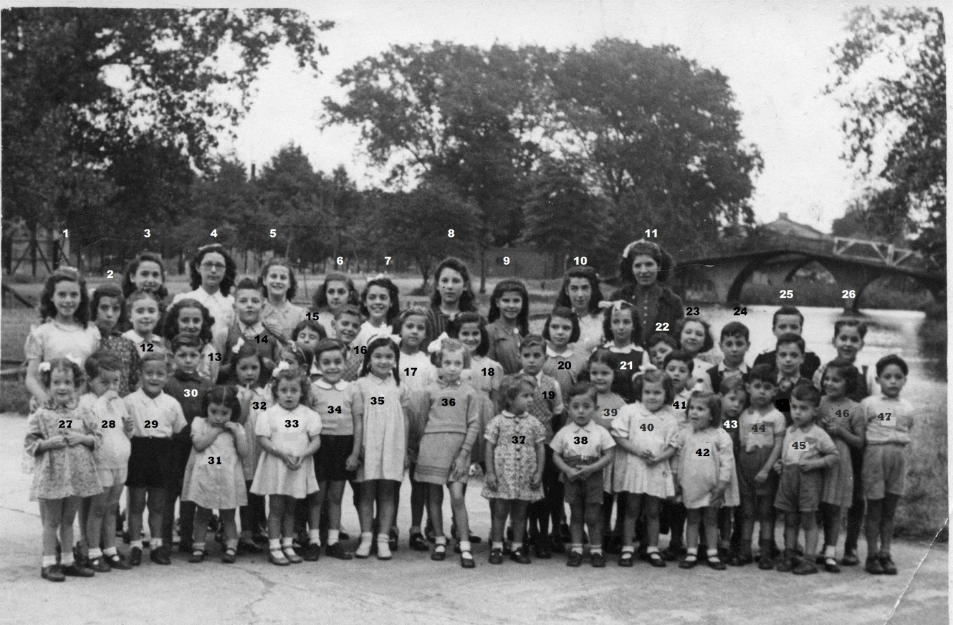
9.Luisa Fortunatom,10.Herminia Cohen,17.Laura Gabay 26.Arthur Wallm, (Dellipiani),29.Joe Robeson,34.Tommy Finlayson,40.Marie Carmen Bossino,39.Pepi Chini, 41.Salvador Mamo 42 Jane Charvetto(Padina)

Ref.L.19.
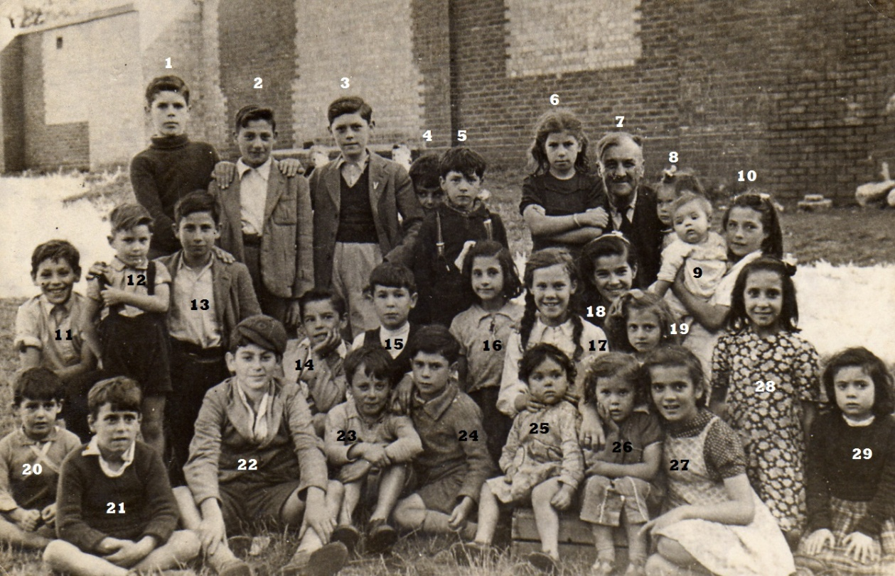
Evacuees at Richmond.
3.Tommy Power 13.Salvador Pitaluga 17.Betty Collins(Garcia)

