Ref .L. 1
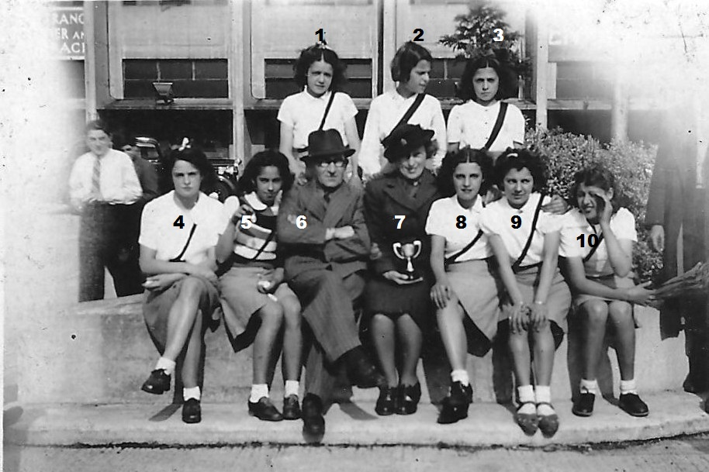
Dr Barnardo’s Netball Team
8. Olga Cornelio 9. Maribel Cornelio, rest not known

Ref.L.2
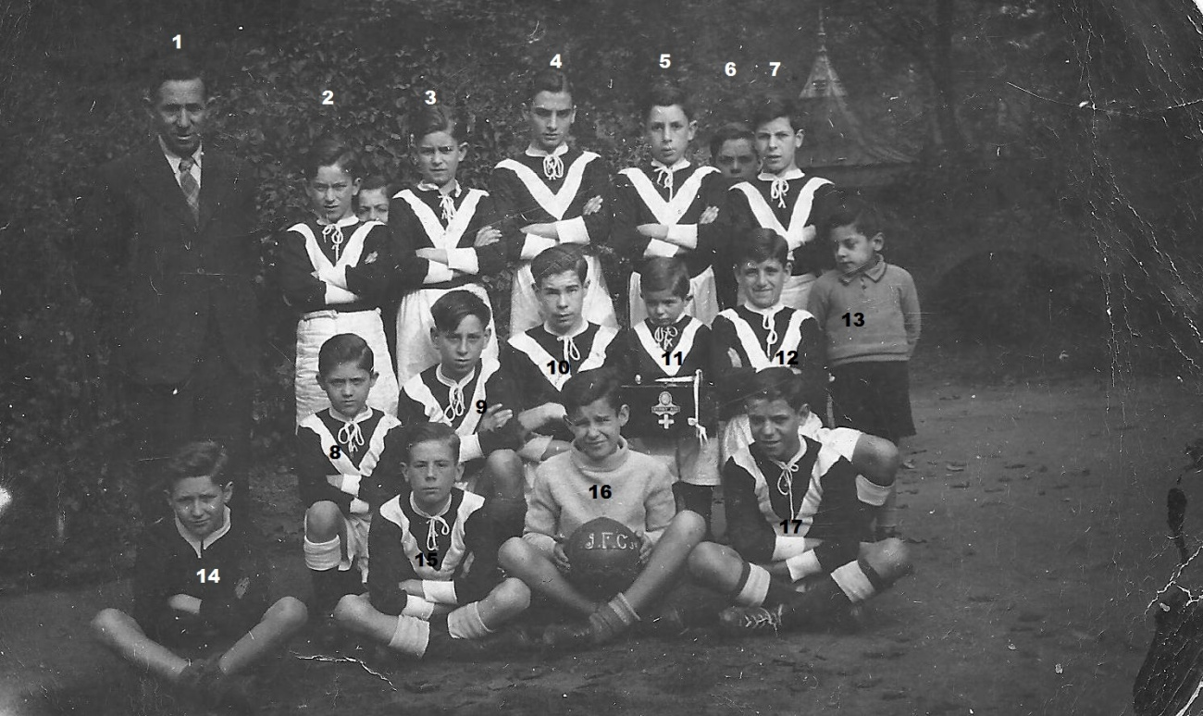
Ivanhoe Junior Football Club
1.Mr A Candeas, rest not known.

