Ref.J.14.
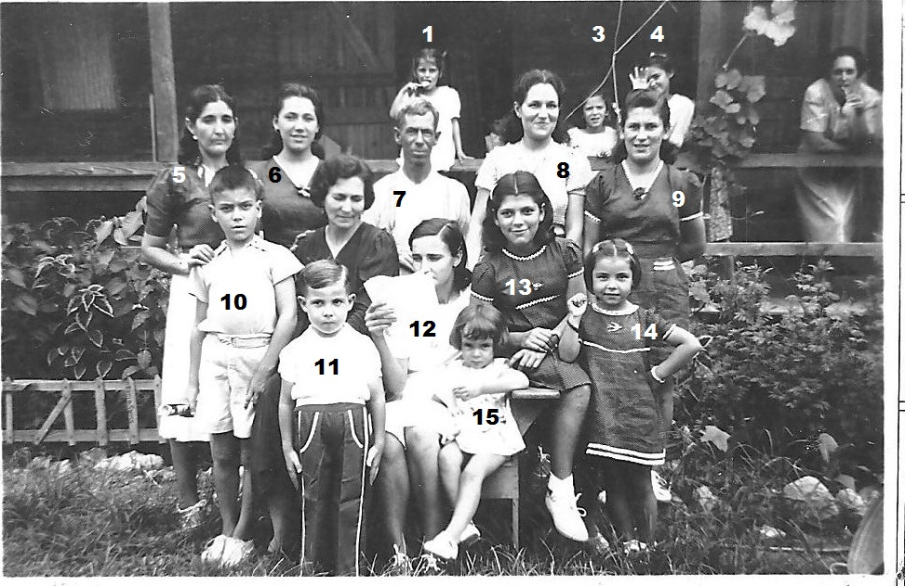
11.J.Enriles rest not known

Ref.J.15.
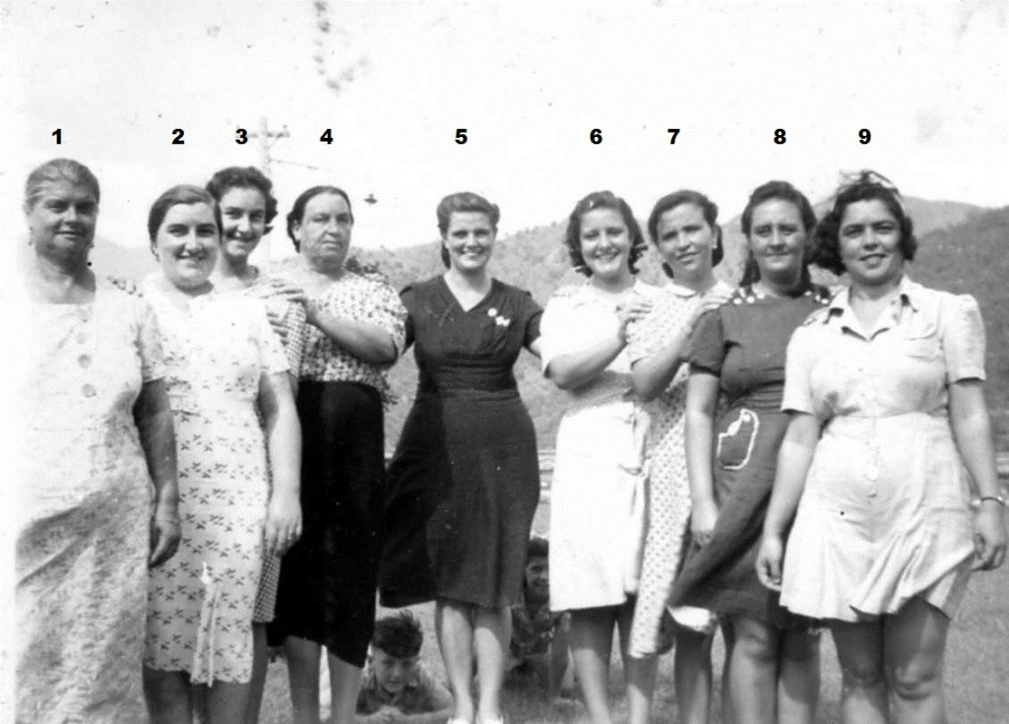
1. ? 2. M.Orcese 3.L.Orcese 4. R.Orcese 5. C.Gomez 6. ? 7. ? 8. ? 9. P.Zammitt

Ref.J.16.
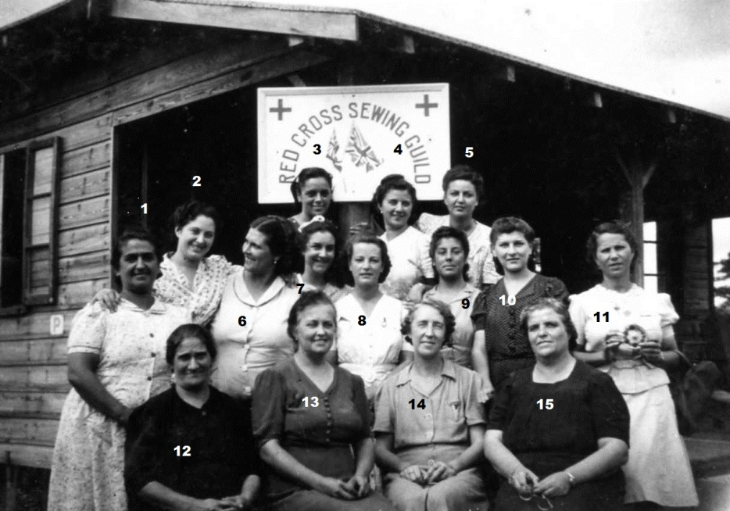
7.L.Orcese rest not know.

